Product Name : 868MHz 2.5dBi Gooseneck Antenna

Model No. G14901A

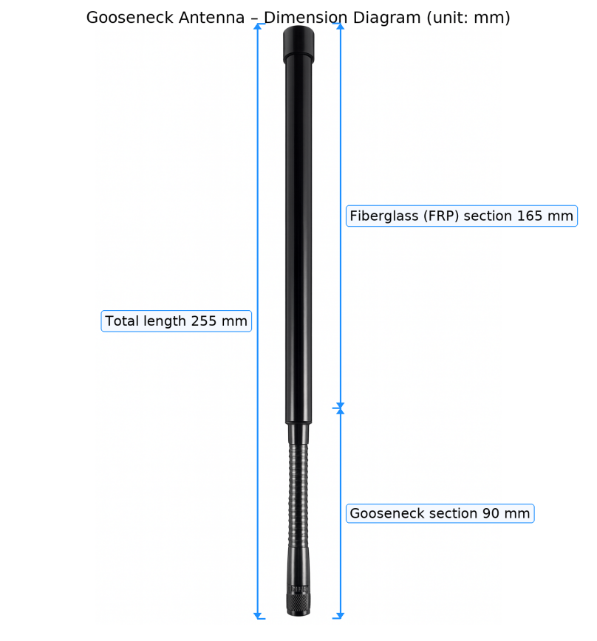

* Outdoor Omni Antenna
* Frequency Band 863-873MHz
* Gain 2.5dBi
* TNC Male
* FPR Firberglass Radome
* 360゜Flexible Gooseneck

|  |  |
| --- | --- |
| **Electrical Specifications** | |
| Model No. | G14901A |
| Frequency Range | 863-873MHz |
| Gain | 2.5dBi |
| VSWR | ≤1.5:1 |
| Input Impedance | 50Ω |
| Polarization | Vertical |
| Horizontal Half Power Angle | 360° |
| Vertical Half Power Angle | 35±5° |
| Max Input Power | 50W |
| Lightning Protection | DC Ground |
| **Mechanical Specifications** | |
| Connector Type | TNC male pin |
| Working Temperature | -40℃~﹢65℃ |
| Antenna Weight | 400±10g |
| Antenna Size | 255*20mm |
| Rated Wind Velocity | 210km/h |
| Antenna cover material | FPR Firberglass |